Week 4 Task1:
import java.util.*;

class Solution {
public boolean halvesAreAlike(String s) {

int count1 = 0;
int count2 = 0;

int mid = s.length() / 2;

for (int i = 0; i < mid; i++) {
if (isVowel(s.charAt(i))) {
count1++;
}
}

for (int i = mid; i < s.length(); i++) {
if (isVowel(s.charAt(i))) {
count2++;
}
}

return count1 == count2;
}

public boolean isVowel(char ch) {
return ch == 'a' || ch == 'e' || ch == 'i' ||
ch == 'o' || ch == 'u' ||
ch == 'A' || ch == 'E' || ch == 'I' ||
ch == 'O' || ch == 'U';
}
}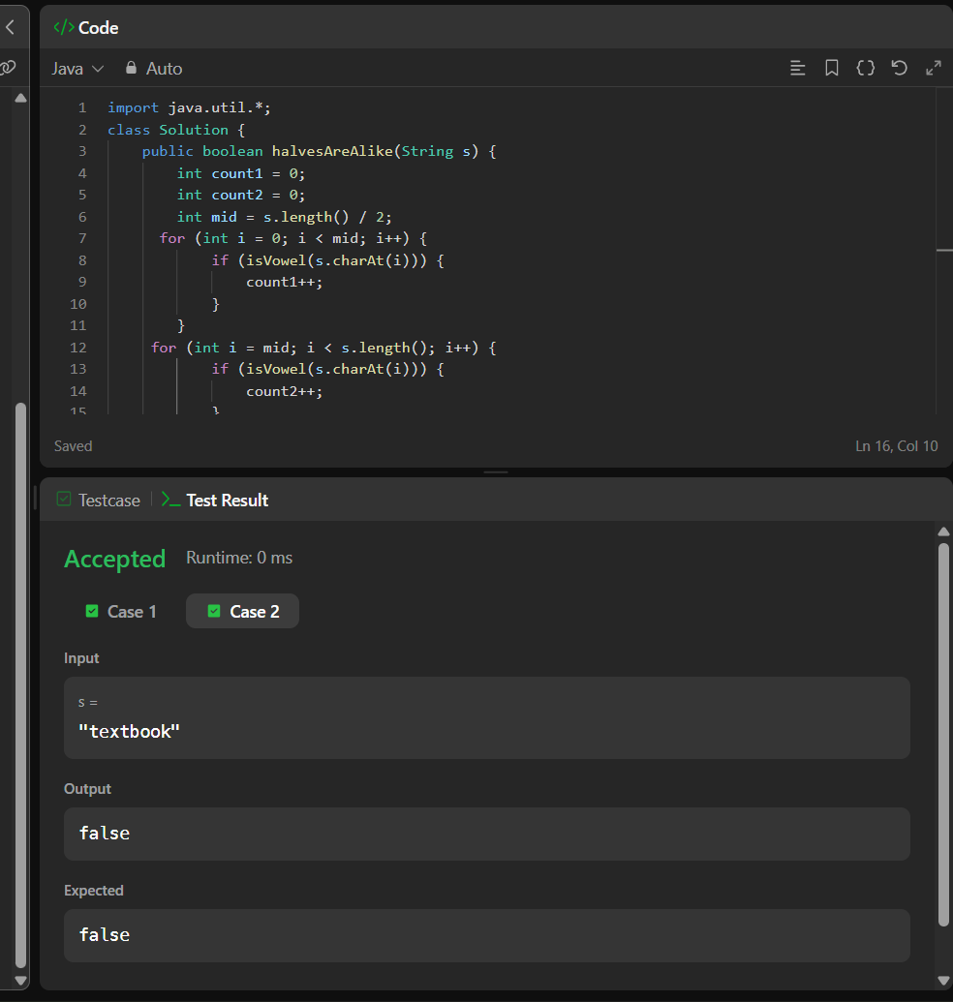

Task 2:
import java.util.*;

public class Main {
public static void main(String[] args) {
Scanner sc = new Scanner(System.in);

int T = sc.nextInt();

while (T-- > 0) {
String s = sc.next();

int n = s.length();
int mid = n / 2;

int[] count1 = new int[26];
int[] count2 = new int[26];

for (int i = 0; i < mid; i++) {
count1[s.charAt(i) - 'a']++;
}

int start;

if (n % 2 == 0) {
start = mid;
} else {
start = mid + 1;
}

for (int i = start; i < n; i++) {
count2[s.charAt(i) - 'a']++;
}

if (Arrays.equals(count1, count2)) {
System.out.println("YES");
} else {
System.out.println("NO");
}
}

sc.close();
}
}